A Triadic Interaction Model with Activity-Verified Identity
for Multi-Domain Gig Economy Platforms

Surjo Santosa Sastroharjono S.T.
PT Liberty Jaya
surjo.sastroharjono@libertyjaya.com
Dr Gunawan Wang S.T., MMSI, M.Ph., M.Com(IS)
Information System Management Department, BINUS Graduate Program -- Master of Information System Management, Bina Nusantara University, Jakarta, Indonesia 11480
gwang@binus.edu

Abstract— The rapid growth of the gig economy has enabled flexible work opportunities across various sectors. However, existing platforms predominantly adopt a two-sided model, focusing on transactions between service providers and consumers, often neglecting the operational and coordination aspects required to sustain recurring and scalable activities. This limitation is particularly evident in event- and activity-based services such as coaching, training, and community-driven engagements, where structured coordination plays a critical role.
This paper proposes a triadic interaction-based platform model that integrates three key actors: skill providers, service consumers, and activity operators. The model introduces activity-oriented execution as the fundamental unit of interaction, supported by an activity-verified identity system that captures participation history, interaction records, and progressive engagement. This identity-centric approach enables gig workers to evolve from individual participants into organized service entities through continuous and structured activity involvement.
Furthermore, the model supports multi-domain participation, allowing users to engage across diverse activity contexts within a unified identity framework. The proposed framework emphasizes interaction orchestration, identity evolution, and scalable participation. A conceptual architecture and use-case scenarios are presented to demonstrate the applicability of the model. This work contributes to the development of next-generation gig economy systems by introducing a structured, identity-driven, and multi-actor interaction paradigm.

Keywords: Gig Economy, Triadic Interaction, Verified Identity, Activity-Based Platform, Multi-Domain Systems, Digital Identity

INTRODUCTION
The gig economy has transformed the nature of work by enabling individuals to provide services on a flexible and on-demand basis. Digital platforms have played a significant role in facilitating interactions between service providers and consumers. Platforms such as Upwork and Airbnb have demonstrated how digital systems can scale service distribution globally [1], [2].
Despite these advancements, most gig economy platforms operate under a two-sided interaction model that focuses primarily on transactional exchanges. This approach is effective for discrete tasks but insufficient for activity-based services such as coaching, workshops, and community programs, which require structured coordination, scheduling, and recurring engagement.
Additionally, identity representation in existing platforms remains largely self-declared. Users present profiles, skills, and experiences that may not be fully verifiable, creating a gap between perceived identity and actual participation. This limitation affects trust, progression tracking, and long-term ecosystem development.
Existing gig economy platforms face several limitations: (1) Lack of integration of operational roles in interaction models; (2) Limited support for structured and recurring activities; (3) Identity systems based on self-declared information; (4) Absence of mechanisms to track progression and real participation
This study aims to: (1) Propose a triadic interaction model integrating providers, consumers, and operators; (2) Introduce activity as the fundamental unit of interaction; (3) Develop an activity-verified identity system; (4) Enable scalable and multi-domain participation.
The contributions of this paper include: (1) A triadic interaction framework for gig economy systems; (2) An activity-verified identity model; (3) A multi-domain interaction approach; (4) A conceptual architecture supporting scalable growth.

LITERATURE REVIEW

Gig Economy Platforms
Gig economy platforms such as Upwork and Airbnb operate on a two-sided interaction model connecting providers and consumers ([1]. While effective for transactional services, they lack support for structured, recurring, and activity-driven interactions [2].

Event-Based Platforms
Platforms like Eventbrite support scheduling and participation in events. However, they treat events as isolated instances and lack mechanisms for identity progression and continuous engagement [3].

2.3 Digital Identity and Authenticity
Existing identity systems rely on profiles and self-declared data. Social media platforms emphasize perception-driven identity, while professional platforms provide structured but still self-reported information [4]. These systems lack verifiable linkage to real-world activity.

Research Gap
The literature reveals key gaps: (1) Absence of triadic interaction models; (2) Lack of activity-based identity systems; (3) No unified framework for multi-domain participation; (4) Limited support for scalable progression of gig workers.

PROPOSAL MODEL

Model Overview
The proposed model introduces a triadic interaction structure, an activity-oriented mode of execution, and an activity-verified identity layer. Together, these elements define a platform logic that is not limited to one-time transactions, but instead supports coordination, continuity, and the accumulation of verified participation history.

Triadic Interaction Structure
The model consists of three primary actors: skill providers, service consumers, and activity operators. Skill providers deliver value by creating or leading activities and contributing their expertise to execution. Service consumers receive value by joining activities, participating in them, and generating participation records through their engagement. Activity operators orchestrate interaction by scheduling activities, managing capacity, and coordinating participants so that execution becomes structured and repeatable.
Table 1 Roles and Responsibilities in Triadic Interaction
Actor | Primary Role | Responsibilities | Output
Skill Provider | Delivers value | Creates and leads activities, provides expertise, ensures quality of execution | Activity delivery, outcomes
Service Consumer | Receives value | Joins activities, participates actively, provides feedback and engagement | Participation records
Activity Operator | Orchestrates interaction | Schedules activities, manages capacity, coordinates participants and logistics | Structured execution

In this triadic structure, the skill provider functions as the actor who delivers value, the service consumer functions as the actor who receives value, and the activity operator functions as the actor who orchestrates the overall interaction. Their respective outputs take the form of activity delivery and outcomes, participation records, and structured execution.

Activity as Core Unit
Activities (events/sessions) are defined as the fundamental unit, supporting scheduling, participation, and repeatability.

Activity-Verified Identity
Identity in the proposed model is constructed from recorded participation, system-validated interactions, and progressive engagement over time. Rather than relying on static self-description alone, the model ties identity to observable and verifiable involvement in platform activities.

Identity Evolution
Users evolve through roles in a gradual sequence that moves from participant to contributor, from contributor to provider, and eventually from provider to operator.
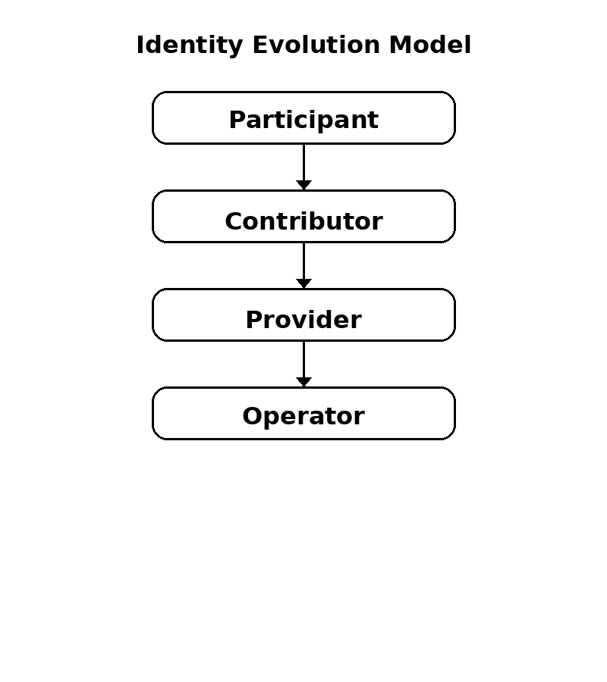
Figure 1 Identity Evolution Model
This figure illustrates the progressive role transition enabled by activity-verified identity, where users evolve through participation, contribution, and increasing responsibility. Each transition is triggered by accumulated, verifiable activity records rather than self-declared status.

System Architecture
The system architecture is composed of an interaction layer, an orchestration layer, and an identity layer. These layers work together to capture actor engagement, organize activity execution, and convert operational history into a persistent identity record.
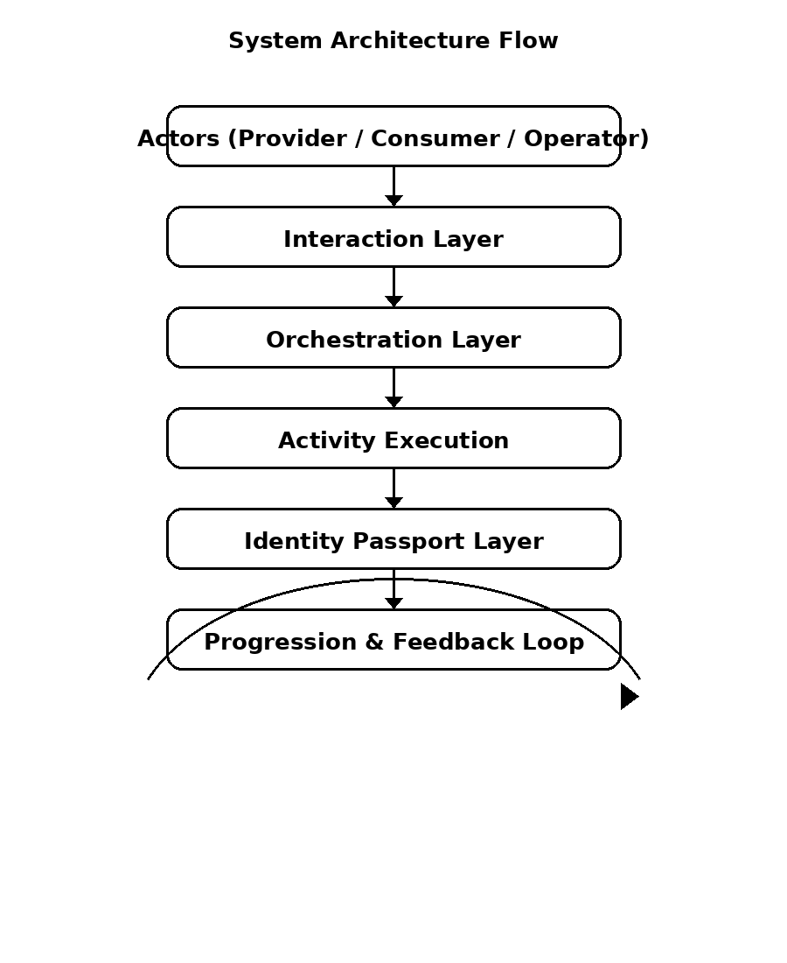
Figure 2 System Architecture Flow (Conceptual)

Identity as Evidence-Based System
In conventional digital platforms, identity is often constructed through self-declared profiles, where users describe their skills, experience, and achievements. While this approach provides flexibility, it introduces a gap between perceived identity and actual participation, as the information is not always verifiable.
In contrast, the proposed model defines identity as an evidence-based system, where each identity record is derived from observable and system-recorded activities. Rather than relying on claims, identity is constructed through verified participation, ensuring that user representation reflects actual involvement within the platform.
This shift transforms identity from a subjective narrative into an objective record of engagement. As a result, trust is not built through self-presentation, but through accumulated evidence of participation, contribution, and responsibility.
Recent developments in digital identity, such as self-sovereign identity and verifiable credentials, emphasize the importance of user-controlled and verifiable identity records [5], [6].

Identity Metrics and Continuity
The activity-verified identity system enables the introduction of continuity metrics, which capture long-term engagement rather than isolated interactions. These metrics provide a structured way to evaluate user progression and participation across activities.
Key identity metrics include:
- Participation Frequency: the number of activities attended or conducted over time
- Consistency: regularity of engagement within a given period
- Role Progression: transition between roles (e.g., participant to provider)
- Engagement Depth: level of involvement within activities (e.g., passive vs active contribution)
These metrics collectively form a continuity-based identity model, where identity evolves as a function of sustained participation. This approach allows the platform to recognize not only what users have done, but also how consistently and meaningfully they engage over time.

Identity as Cross-Domain Asset
In the proposed model, identity is not confined to a single domain of activity, but instead functions as a cross-domain asset. Each activity, regardless of its context—such as fitness training, educational seminars, or creative exhibitions—contributes to a unified identity record.
This cross-domain accumulation enables users to build a more holistic representation of their capabilities, combining diverse forms of participation into a single, coherent identity. For example, a user who participates in educational activities may later transition into a provider role in a different domain, supported by their accumulated experience and engagement history.
As a result, identity becomes transferable across contexts, allowing users to leverage their participation history beyond a single domain. This characteristic distinguishes the proposed model from conventional platforms, which typically restrict identity to domain-specific interactions.

USE CASE AND DISCUSSION

Fitness Ecosystem
A coach conducts training sessions managed by an operator, with participants joining activities. Participation is recorded, and identity evolves over time.

Multi-Domain Participation
Users may attend fitness sessions, join seminars, and organize art exhibitions within the same platform environment. Even though these activities belong to different domains, all of them contribute to a unified identity that reflects the user's broader history of participation and responsibility.

Education and Knowledge-Sharing Scenario
Beyond fitness ecosystems, the proposed model can be applied to educational and knowledge-sharing environments. In this scenario, instructors act as skill providers, participants join learning sessions, and operators manage scheduling and coordination.
Over time, participants who consistently engage in learning activities may transition into contributors, such as discussion facilitators, and eventually into providers who lead sessions themselves. This progression demonstrates how identity evolution is supported not only within a single domain but also across different types of activities.
This use case highlights the flexibility of the model in supporting structured learning environments while maintaining a continuous and verifiable identity system.

Continuous Engagement
The system creates a continuous loop in which activity leads to participation, participation leads to recorded evidence, recorded evidence strengthens identity, and identity in turn opens the way for new activities and opportunities.
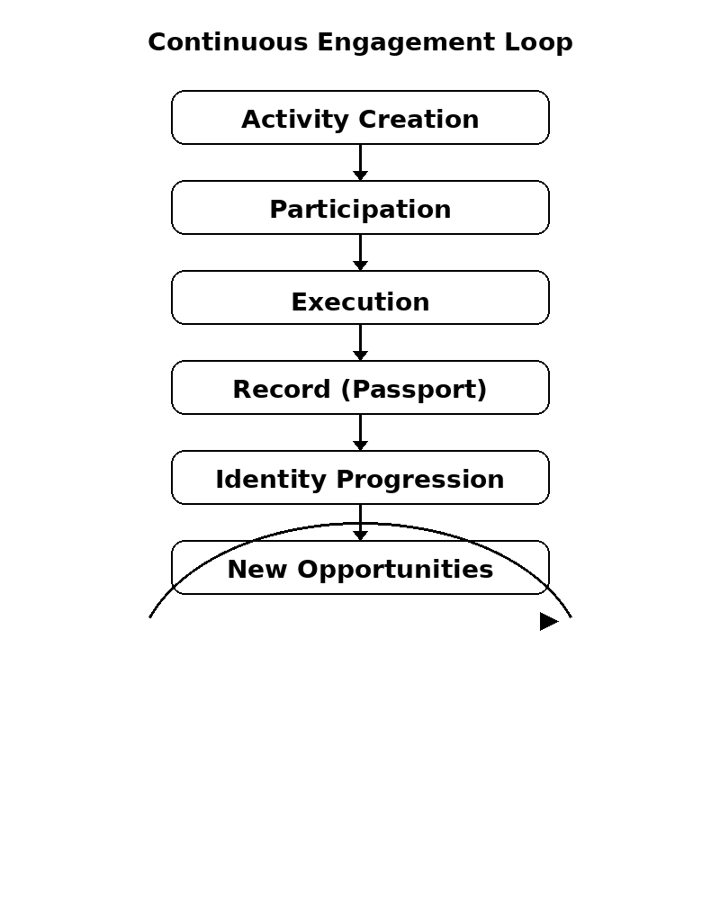
Figure 3 Continuous Engagement Loop

Comparison with Existing Platforms
Compared with traditional gig platforms, the proposed model moves beyond a two-sided interaction pattern and adopts a triadic one. It also differs from conventional event platforms by treating activity, rather than the isolated event, as the central unit of work. In identity terms, traditional gig platforms tend to rely on profile-based representation, while event platforms provide only minimal identity continuity. The proposed model instead uses activity-verified identity as a core feature. Progression, which is often external or weakly supported in other platforms, becomes built into the system itself. The model also supports multi-domain participation rather than limiting users to a single context, and it places coordination at the center of the platform rather than treating it as a secondary concern.

Discussion
Overall, the model shifts the platform logic from transaction to interaction, from profile-based representation to verified identity, and from isolated activity to a continuous ecosystem of participation and progression.

Broader Implications
The proposed model has broader implications for the design of digital platforms and identity systems.
First, it enables gig workers to transition from isolated service providers into participants within structured ecosystems, supporting long-term growth and sustainability. Second, it introduces a shift in platform design from transaction-oriented systems to interaction-driven environments, where value is generated through continuous engagement.
Finally, the model redefines digital identity by emphasizing evidence-based representation, where identity is constructed from verifiable activity rather than self-declared information. This shift has the potential to improve trust, transparency, and accountability in digital platforms.

Prototype Implementation
To validate the feasibility of the proposed model, a prototype application has been developed based on the triadic interaction structure and activity-verified identity concept.
The application implements the core components described in the model, including:
- Triadic interaction flow, where providers, consumers, and operators are explicitly represented within each activity
- Activity management system, enabling scheduling, participation tracking, and execution of sessions
- Identity recording mechanism, where user participation is automatically captured and stored as part of a persistent identity record
Within the system, each activity generates structured data that contributes to the user’s identity. Unlike conventional platforms where users manually input their experience, the prototype ensures that identity is constructed from system-recorded participation.

Implementation Overview
The prototype is designed as a modular platform consisting of:
- A user interaction layer for managing participation and activity engagement
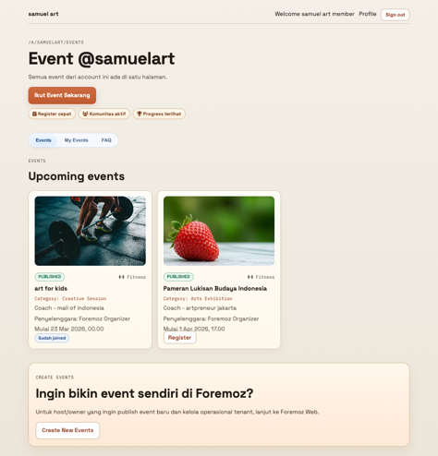



- An activity orchestration module for scheduling and coordination


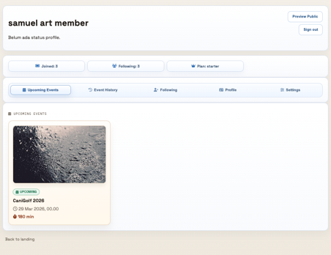
- An identity layer that accumulates participation records and supports progression tracking
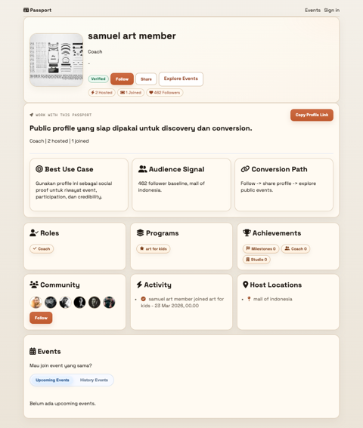

This architecture reflects the conceptual model proposed in Section 3 and demonstrates its practical applicability.

Observations from Implementation
Initial implementation highlights several key observations:
- Structured Coordination Improves Participation
- The presence of an operator role enables more organized and repeatable activities compared to ad-hoc interactions.
- Identity Becomes Naturally Accumulative
- Users do not need to manually update their profiles, as identity is automatically constructed from participation.
- Progression Emerges Organically
- Users who participate more frequently tend to evolve into higher roles, validating the identity evolution model.
- Multi-Domain Integration is Feasible
- The system supports different types of activities within a unified identity framework, confirming the generalizability of the model.

Implication
The prototype demonstrates that the proposed model is not only conceptual but also implementable. It provides early validation that a triadic, activity-based, and identity-driven platform can support scalable participation and continuous engagement in real-world scenarios.

CONCLUSION AND FUTURE WORK

Conclusion
This paper presents a triadic interaction model with activity-verified identity, enabling structured, scalable, and multi-domain gig economy participation. The model addresses limitations of existing platforms and introduces a new paradigm based on interaction and verified identity.

Future Work
Future research should focus on prototype implementation, empirical validation, integration with verification technologies, and expansion across industries. These directions are necessary to test the operational feasibility of the model and to assess its broader applicability in real-world gig economy contexts.

REFERENCES
[1] O. Kässi and V. Lehdonvirta, “Online labour index: Measuring the online gig economy for policy and research,” Technol. Forecast. Soc. Change, vol. 137, pp. 241–248, Dec. 2018, doi: 10.1016/j.techfore.2018.07.056.
[2] Arun. Sundararajan, The sharing economy : the end of employment and the rise of crowd-based capitalism. The MIT Press, 2016.
[3] Donald. Getz and Stephen. Page, Event studies : theory, research, and policy for planned events. Routledge, 2016.
[4] danah m. boyd and N. B. Ellison, “Social Network Sites: Definition, History, and Scholarship,” Journal of Computer-Mediated Communication, vol. 13, no. 1, pp. 210–230, Oct. 2007, doi: 10.1111/j.1083-6101.2007.00393.x.
[5] Christopher Allen, “The Path to Self-Sovereign Identity.” Accessed: Mar. 27, 2026. [Online]. Available: https://www.lifewithalacrity.com/article/the-path-to-self-soverereign-identity/
[6] “Verifiable Credentials Data Model v1.1,” w3.org. Accessed: Mar. 27, 2026. [Online]. Available: https://www.w3.org/TR/vc-data-model-1.1/

